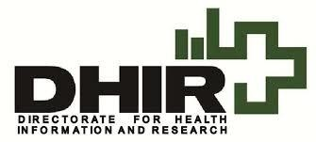
World Birth Defects Day 2026
Every Journey Matters
Down Syndrome

Introduction
World Birth Defects Day (WBDD), first commemorated on March 3, 2015, is an annual global initiative aimed at increasing awareness about birth defects and promoting prevention, research, treatment, and support services. The day serves as a reminder that behind every affected individual is a personal story that deserves compassion, understanding, and appropriate care. More information is available at: worldbirthdefectsday.org.
Each year, an estimated 8 million babies worldwide are born with a congenital anomaly. These conditions develop during fetal life and are therefore present at birth. Reported rates vary across countries, with some evidence indicating lower prevalence in more developed regions and higher rates in the least developed (Yu et al., 2015).
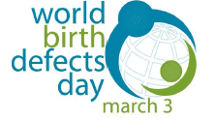
Congenital anomalies are thought to account for around 240,000 deaths during the early neonatal period (0–27 days) and an additional 170,000 deaths among children under five (WHO, 2023). Many of those who survive may experience chronic and often lifelong functional limitations, placing considerable strain on their health and creating significant psychosocial, societal, and economic challenges for families, communities, and healthcare systems.
Although the causes of many congenital anomalies remain unknown, various evidence-based preventive measures can help reduce risk. Health-promoting behaviours—such as achieving a healthy weight before conception, avoiding tobacco and alcohol use during pregnancy, keeping immunisations up to date, and ensuring adequate periconceptional intake of folic acid and other key micronutrients—have been shown to lower the likelihood of certain congenital anomalies (Abebe et al., 2021).
Ongoing research remains vital to improving scientific understanding, enhancing prevention strategies, guiding policy development, and strengthening clinical care and support services.
In Malta, major birth defects are systematically monitored through the Malta Congenital Anomalies Register (MCAR), maintained by the Directorate for Health Information and Research (DHIR). The register includes all babies born with one or more major congenital anomalies diagnosed up to one year of age. Healthcare professionals are encouraged to report cases using the Notification of Congenital Anomalies Form available at: https://dhir.gov.mt/en/forms/ . Further information on MCAR can be found at: https://dhir.gov.mt/en/registries/congenital-anomalies/ .

Down syndrome
What is Down syndrome?
Down syndrome is the most common congenital anomaly caused by abnormalities in chromosomes. It is also known as Trisomy 21, and results from the presence of an extra partial or full chromosome 21. This change in the number of total chromosomes has effects across many organ systems.
Health risks in people with Down syndrome include (WHO, 2023):
- Congenital heart defects (seen in about 50% of affected newborns)
- Digestive system issues
- Low muscle tone, contributing to delayed motor milestones
- Hearing and vision problems, including increased risk for cataracts
- Thyroid dysfunction
- Increased risk of infections due to weak immune system
- Neck joint instability
- Increased risk for certain cancers, including leukemia
- Earlier onset of Alzheimer’s disease
- Sleep disorders, epilepsy, and mental health challenges
Down syndrome is also associated with intellectual and developmental delays. Not every individual with Down syndrome experiences all of these health conditions. Despite these risks, many people with Down syndrome live into their 60s and beyond. With proper support, people with Down syndrome can thrive across the domains of autonomy, social relationships, learning, and physical well-being.

Risk factors for Down syndrome
The most important factor that increases the likelihood of having a baby with Down syndrome is the mother’s age. The increasing prevalence of Down syndrome in Europe is associated with the trend of postponing giving birth until an older age. In Malta, the average maternal age has steadily increased by about 2 months each year.
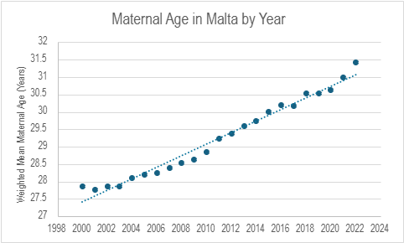
Analysing data for Malta, mothers aged 45 years and older have approximately 107 times the odds of having a baby with Down syndrome compared to mothers aged 20-24 years. However, it is important to clarify:
- While this number seems large, only around 3.8% of all births in the 45+ maternal age group will be to a baby with Down syndrome.
- Most babies with Down syndrome are actually born to younger mothers, simply because this group accounts for the majority of total births.
Nonetheless, the likelihood of having a child with Down syndrome rises exponentially with increasing maternal age, especially after age 35.
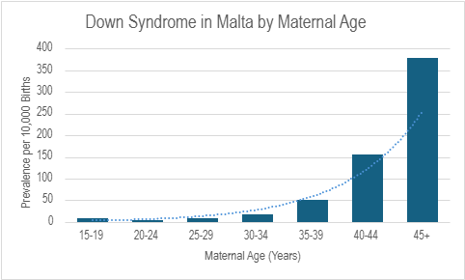

While factors related to the father (diet, genetics, environmental exposures) may play a role, it is thought that only about 10% of Down syndrome cases are of paternal origin. Family history of genetic conditions and a previously affected birth also increase the likelihood, although most cases are spontaneous, meaning not passed down within families.

How common is Down syndrome in Malta?
Data collected between 2010 and 2019 show that chromosomal anomalies, which include Down syndrome, are the fifth most common congenital anomaly group in Malta, affecting 29.22 in 10,000 births (or around 3 in every 1000 births). When considering total cases of Down syndrome (including live births, still births, and terminations of pregnancy), Malta’s rate is similar to the EU average. However, when considering only live births, the EU average drops, while Malta stays virtually the same, making the live birth prevalence higher in Malta (EUROCAT network https://eu-rd-platform.jrc.ec.europa.eu/eurocat/eurocat-data/prevalence_en). This is likely explained by differences in legality regarding termination of pregnancy due to fetal anomaly (TOPFA). TOPFA is legal in most EU countries but is not legal in Malta.

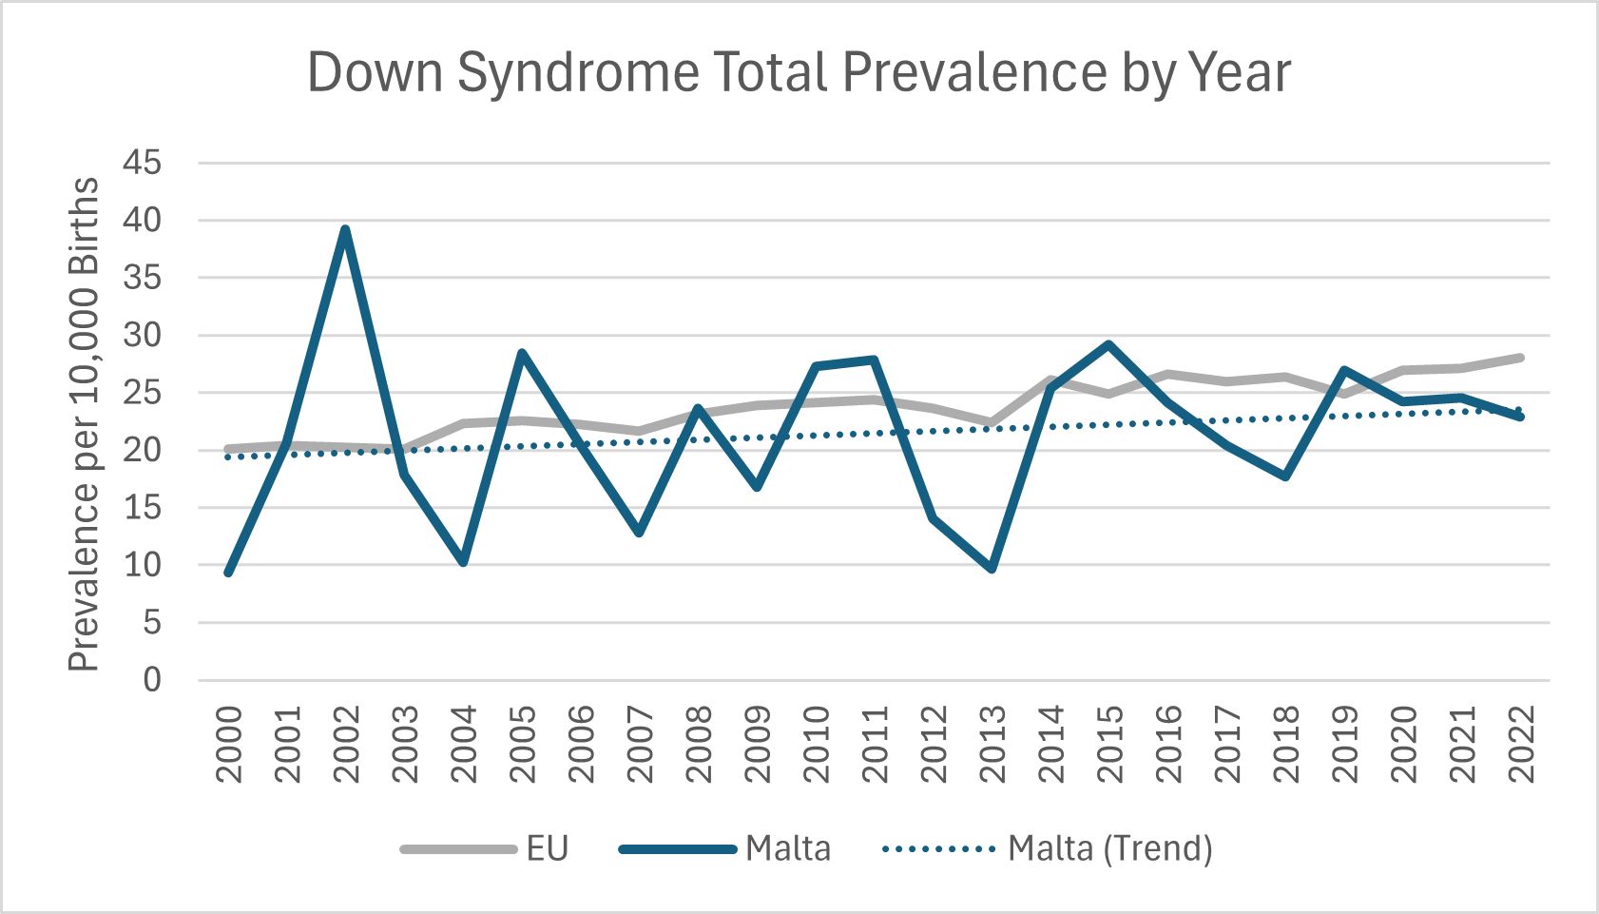
Data from EUROCAT: https://eu-rd-platform.jrc.ec.europa.eu/eurocat/eurocat-data/prevalence_en and Malta Congenital Anomalies Registry

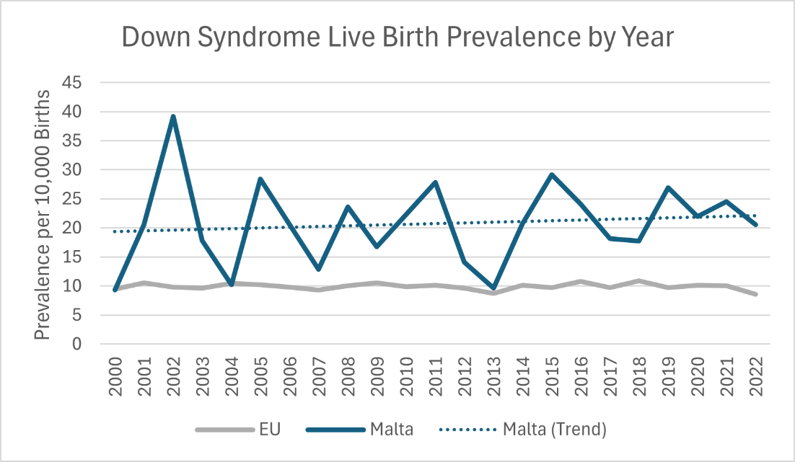
Data from EUROCAT: https://eu-rd-platform.jrc.ec.europa.eu/eurocat/eurocat-data/prevalence_en and Malta Congenital Anomalies Registry

After Diagnosis: Guidance and Resources
Down syndrome can be detected during pregnancy by ultrasound and prenatal screening, which gives families time to seek counselling and plan for supportive interventions after birth. Seeking intervention services early in life reduces risk of health complications down the line.
Physical therapy can improve motor control, which is crucial for those with low muscle tone as a part of Down syndrome. Furthermore, individuals with Down syndrome often develop unusual movement patterns that can cause joint problems with time, and physical therapy encourages safer movements. Low muscle tone and a large tongue can make it difficult for babies with Down syndrome to breast or bottle feed, but feeding specialists can help. Speech therapy and occupational therapy should also be a part of the comprehensive care of people with Down syndrome (National Down Syndrome Society).
The Child Development Assessment Unit offers many of these services, and being part of the public sector, it is provided on a national level and financed by government. In Malta, children at risk of developmental delay are eligible for the Early Intervention Service from birth until age 5 to help them reach developmental milestones.
Children with Down syndrome are encouraged to attend mainstream education, where they can receive assistance from a Learning Support Educator. Financial allowances are available from the Department of Social Security. These services help individuals with Down syndrome reach their potential and enhance quality of life.
Public awareness and evidence-based policy can ensure that every child born with Down syndrome is given the best possible start in life.

References:
Abebe, S. et al. (2021) ‘Risk factors associated with congenital anomalies among newborns in southwestern Ethiopia: A case-control study’, PLOS ONE, 16(1), p. e0245915. Available at: https://doi.org/10.1371/journal.pone.0245915.
American Academy of Pediatrics (2022). Health supervision for children with Down syndrome. Available at: https://doi.org/10.1542/peds.2022-060999
Centers for Disease Control and Prevention (2022). Down syndrome. U.S. Department of Health and Human Services. Available at: https://www.cdc.gov/birth-defects/about/down-syndrome.html
EUROCAT network Prevalence charts. Available at: https://eu-rd-platform.jrc.ec.europa.eu/eurocat/eurocat-data/prevalence_en
National Down Syndrome Society. (n.d.). Early intervention. https://ndss.org/resources/early-intervention
World Health Organization. Congenital Disorders – Key Facts. WHO Fact Sheet, 27 February 2023. Available at:
https://www.who.int/news-room/fact-sheets/detail/birth-defects
Yu, M. et al. (2015) ‘The Survey of Birth Defects Rate Based on Birth Registration System’, Chinese Medical Journal, 128(1), pp. 7–14. Available at: https://doi.org/10.4103/0366-6999.147785

Compiled by: Ms Taylor Aldeghi, Dr Miriam Gatt.
Malta Congenital Anomalies Register, Directorate for Health Information and Research, MALTA
March 2026

